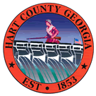

Hart County Board of Commissioners

Called Meeting Tuesday September 30, 2025, At 5:00 PM at the Administrative and Emergency Services Building

1. Public Hearing for the FY 26 General Fund Budget
2. Approval of The FY 26 M&O Budget
3. Tentative Draft Lost Rollback Rate
4. Tentative Draft Millage Rate
5. Other Items as time allows